

**Diploma in**

Electronics, Computer & Communications Engineering

Final Year Project Report

**Project Title:**

Le Door

**Project Supervisor:**

Mr. Leong Kuan Jeet

**Project Student:**

Muhammad Hanafi Bin Mokhri

**Table of Contents**

1. Acknowledgment.
2. Introduction
   1. Background / System Overview
3. Project Objective
4. Project Scope
5. Software Development
   1. App setup guide
   2. App development guide
   3. App block codes explained
   4. Arduino code explained

5. Hardware devolepment

6. Key Technical Issues

7. Solutions

8. Future Implementations.

9. Conclusion.

Acknowledgment

Thanks to Mr. Leong Kuan Jeet. He has helped me a lot for this project by providing me with necessary parts and guidance. And also being understanding.

**System Overview**

In today’s era, technology can be used to make everyday activities much more convenient. By combining your smartphone and an Arduino board and a door latch, a door lock system can be implemented.

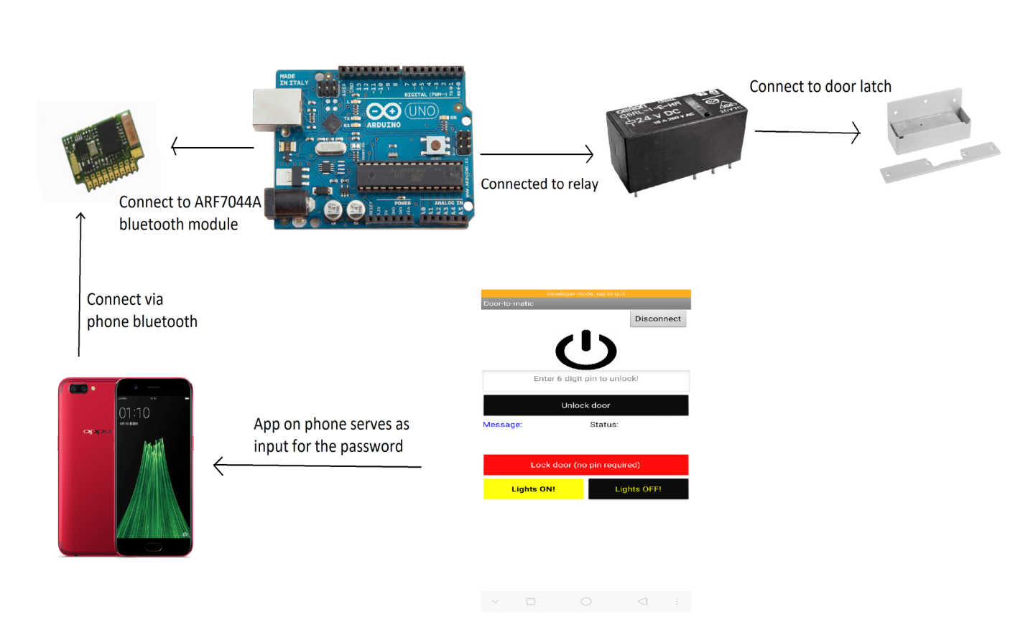

Overview:

The system built around Arduino and MIT App Inventor provides easy access and security using your smartphone to lock and unlock doors when needed.

**Background Information**

The Arduino UNO is a widely used open-source microcontroller board based on the [Microchip](https://en.wikipedia.org/wiki/Microchip_Technology) [ATmega328P](https://en.wikipedia.org/wiki/ATmega328P) microcontroller and developed by [Arduino.cc](https://en.wikipedia.org/wiki/Arduino). It can be used to create many different kinds of electronic devices, gadgets, etc.

It has the following technical specs:

* [Microcontroller](https://en.wikipedia.org/wiki/Microcontroller): [Microchip](https://en.wikipedia.org/wiki/Microchip_Technology) [ATmega328P](https://en.wikipedia.org/wiki/ATmega328P)
* Operating Voltage: 5 Volt
* Input Voltage: 7 to 20 Volts
* Digital I/O Pins: 14 (of which 6 provide PWM output)
* Analog Input Pins: 6
* DC Current per I/O Pin: 20 mA
* DC Current for 3.3V Pin: 50 mA
* [Flash Memory](https://en.wikipedia.org/wiki/Flash_Memory): 32 KB of which 0.5 KB used by [bootloader](https://en.wikipedia.org/wiki/Booting#BOOT-LOADER)
* [SRAM](https://en.wikipedia.org/wiki/Static_random-access_memory): 2 KB
* [EEPROM](https://en.wikipedia.org/wiki/EEPROM): 1 KB
* Clock Speed: 16 MHz
* Length: 68.6 mm
* Width: 53.4 mm
* Weight: 25 g

**Project Objective**

To develop a smart locking device using your mobile phone and Arduino.

Key Features

* The phone has an app to enter password, to lock and unlock the door latch. And to control the lights.

Software Development

* Make sure the Arduino program is already uploaded into the board.
* Pair the phone with the Bluetooth module.
* Install the app on the phone.
* Run the app and select the Bluetooth module.

App Development.

Created an app using **MIT App Inventor 2** , a browser based platform which allows you to develop apps on the web and test it in real time on your phone. Then once you complete the app, you can download the apk file of it to install on your android phone.

Unfortunately it doesn’t support IOS as of 14/8/2018. In case you wanted to develop for IOS, I suggest using [thunkable](https://thunkable.com/).

**SETUP guide**:

Step 1: Download app inventor for windows PC by using this link: <http://appinv.us/aisetup_windows>

(note that hyperlinks url might change in the future and if you can’t download it using this link then just go to the MIT app inventor 2 site to download. Make sure it’s the windows version of course. Unless the school changes it to a mac/linux, then in that case download the mac/linux version. *Hint: use google to find it*)

Step 2: Then install it by opening the file you just downloaded.

(Just install it in default state. If for some reason you don’t know how to install it, then check this link out: <http://appinventor.mit.edu/explore/ai2/windows.html> *Hint: Just click yes, next or finish to everything and install in 32 bit if prompted*)

Step 3: Download and install the MIT AI2 Companion App on your phone.

(Search “MIT AI2 Companion” on the google play store or use this link: <https://play.google.com/store/apps/details?id=edu.mit.appinventor.aicompanion3>

If link doesn’t work, then try scanning this QR code: 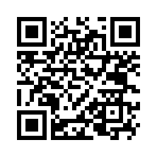)

Step 4: On windows PC, launch aiStarter by clicking on this icon:

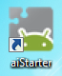 If you can’t find it, or don’t know where to find it, then it should be in here if you followed the default installation: C:\Program Files (x86)\AppInventor.

If not then find it on your desktop or start menu.

If you still can’t find it there, then search “aiStarter” on the start menu.

So after launching aiStarter, you should see a window like this:

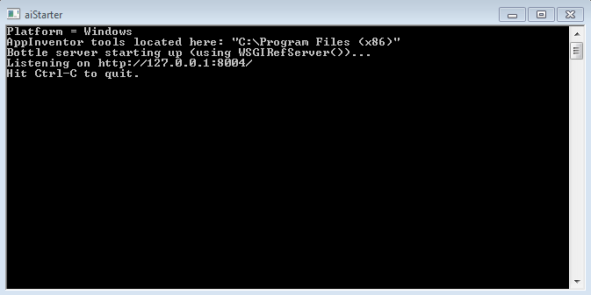

Step 5: On your android phone, turn USB Debugging ON.

Now depending on your android phone, this could be the hardest part. But if you happen to be using an oppo R11s it will go like this (from left to right) :

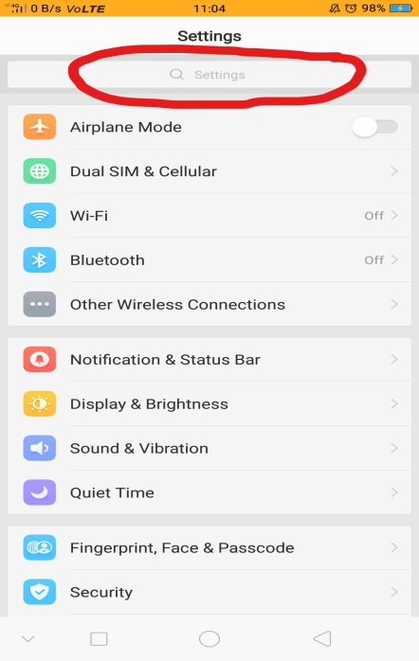 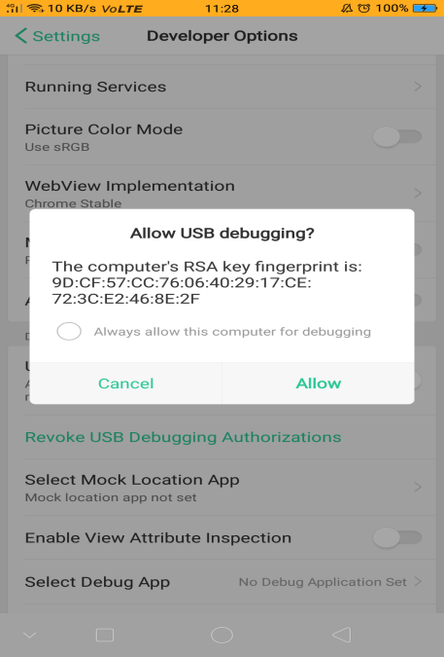

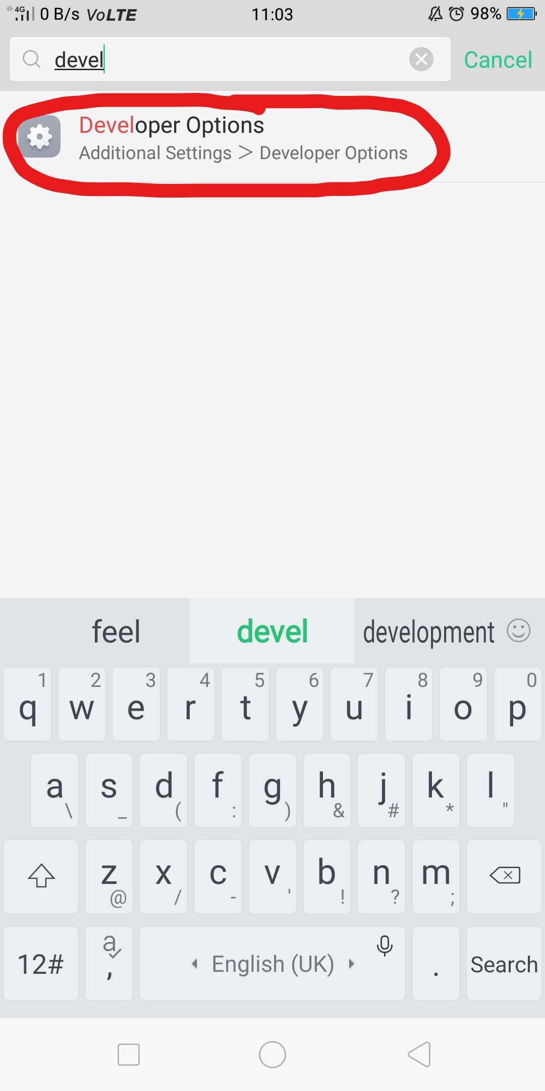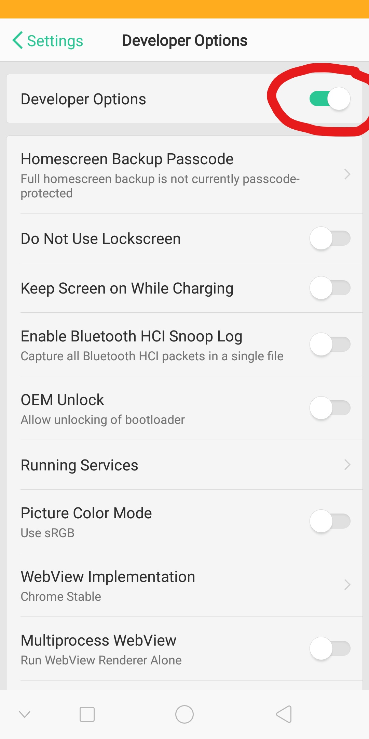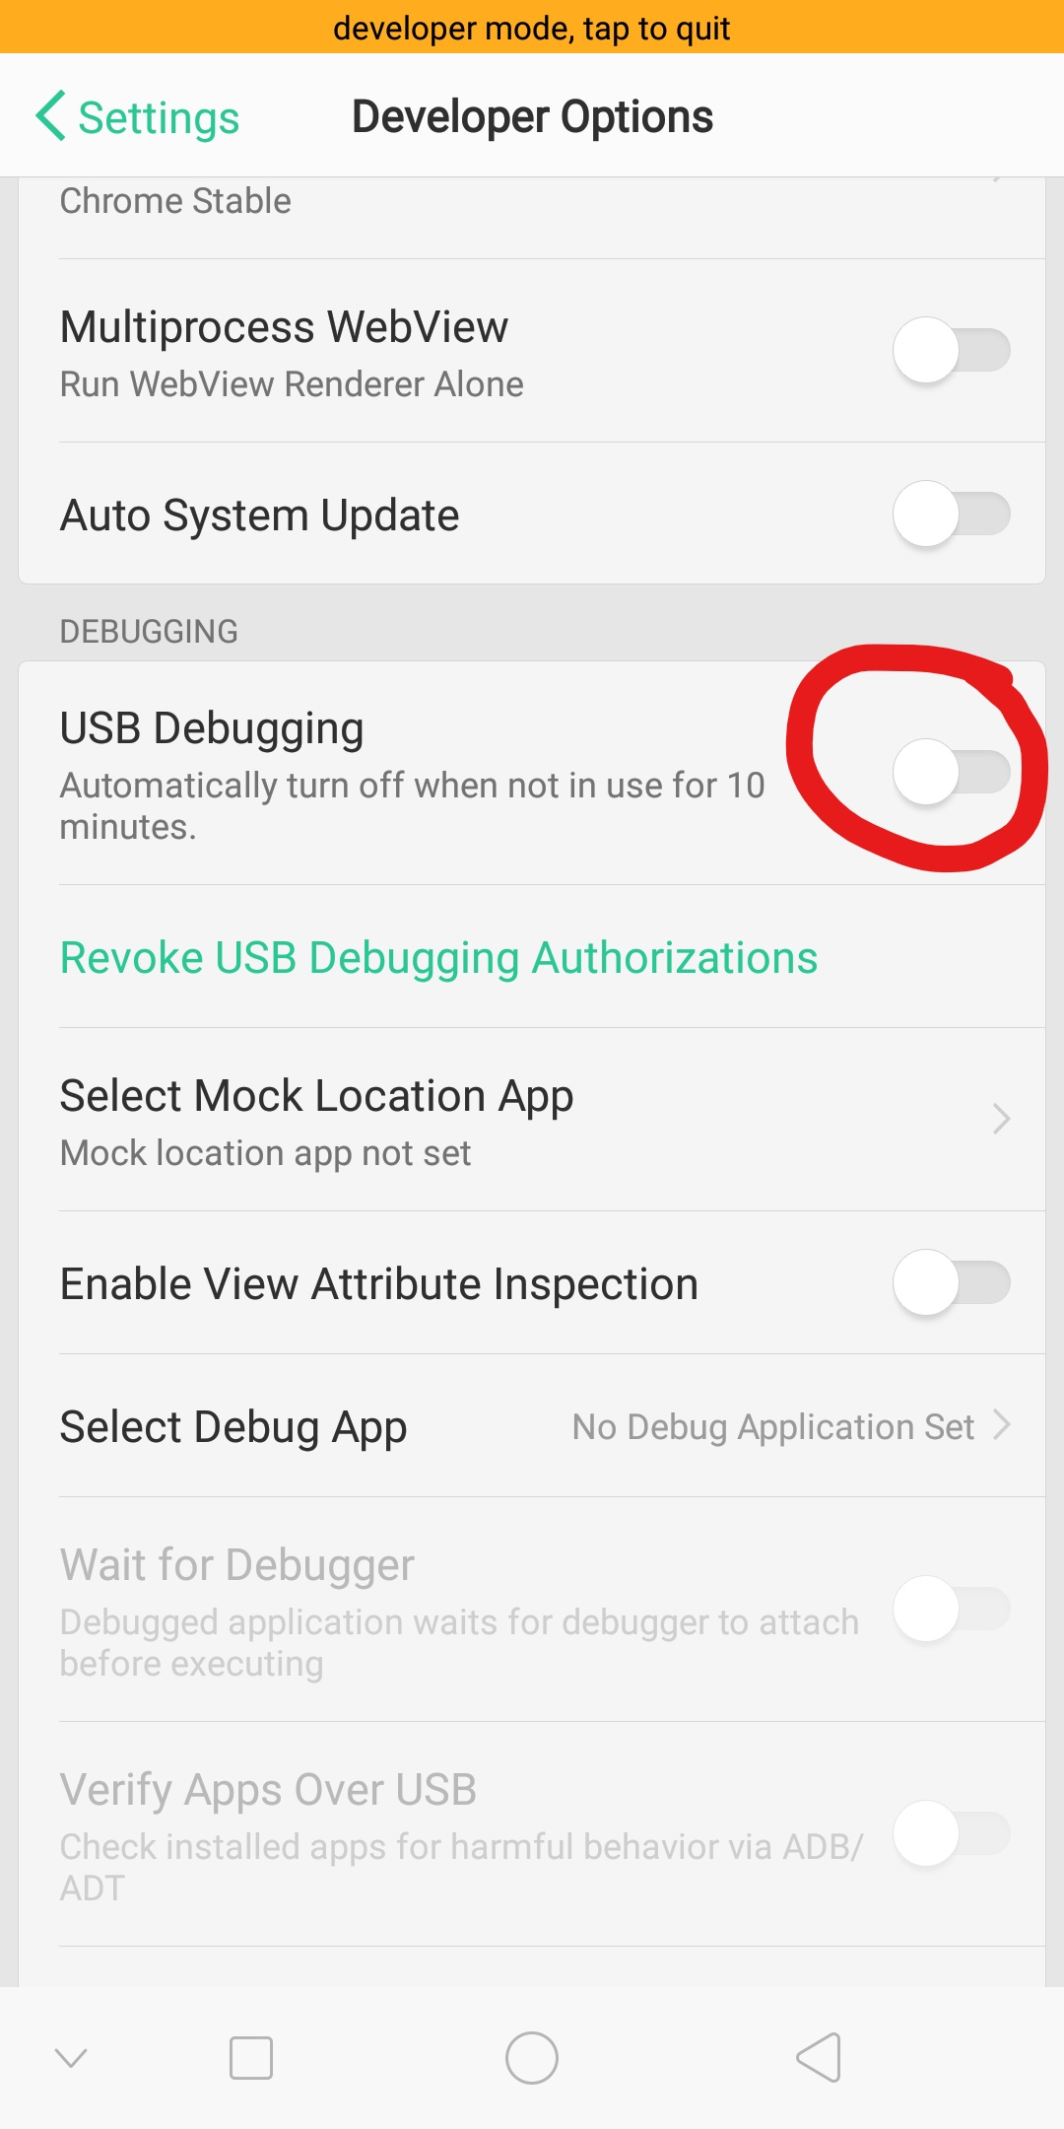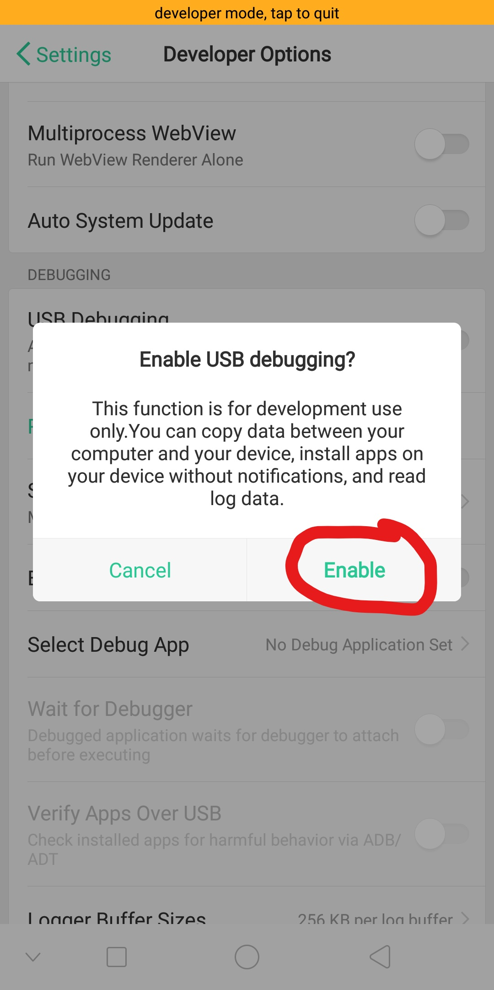

If you’re not using oppo r11s usually it goes like this:

On your Android device, go to System Settings, Developer Options, turn them on, and be sure that "USB Debugging" is allowed.

On most devices running Android 3.2 or older, you can find this option under Settings > Applications > Development.

On Android 4.0 and newer, it's in Settings > Developer options.

On Android 4.2 and newer, Developer options is hidden by default. To make it available, go to Settings > About phone and tap Build number seven times. Return to the previous screen to find Developer options, including "USB Debugging".

If you still can’t find it, then google your phone model because this one depends on the model and build.

Step 6: Connect your android phone to the pc via USB. And connect it as a mass storage device and allow USB Debugging.

Make sure that the device connects as a "mass storage device" (not "media device").

On Android 4.2.2 and newer, your device will pop up a screen with the message Allow USB Debugging? the first time you connect it to new computer. Press "OK". This authenticates the computer to the device, allowing the computer to communicate with it. You'll need to do this for each computer you want to connect to the device, but only once per computer.

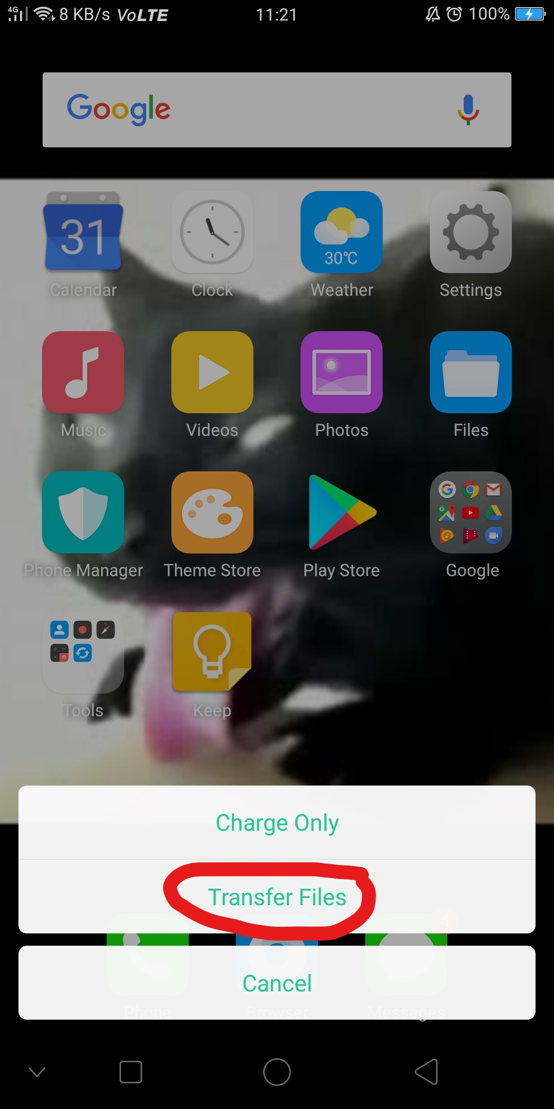

Step 7: Test the connection by clicking this link:

<http://appinventor.mit.edu/test/>

It should show this screen:

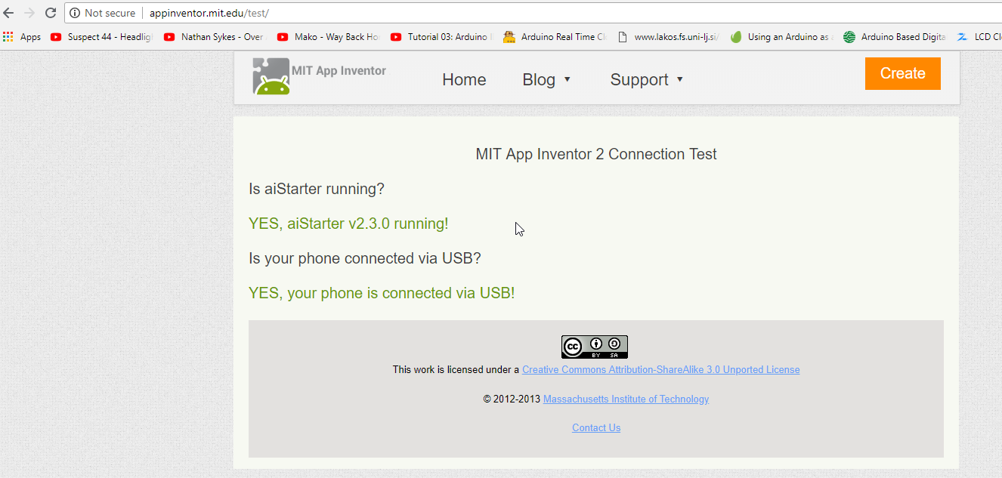

Step 8: You can start developing apps using this link: <http://ai2.appinventor.mit.edu/>

Setup Complete. Now moving on to the development of apps and stuff.

**End of SETUP guide.**

**APP DEVELOPMENT guide**:

Step 1: Open the app inventor using this link and log in: <http://ai2.appinventor.mit.edu/>

(Note: Log in using your google account)

Step 2: Then click projects > Start new project.

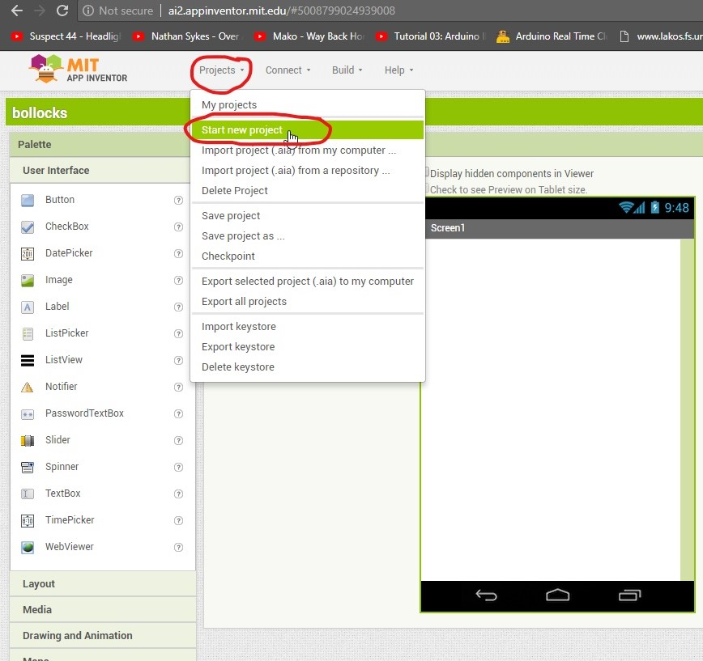

Step 3: Name it whatever you want (project name, your name, anything, doesn’t really matter).

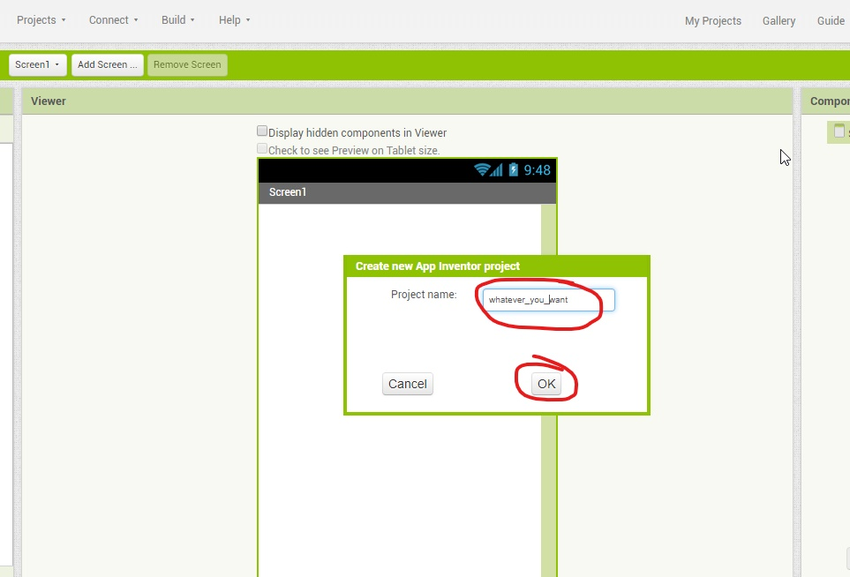

Step 4: On your android phone, enable developer options and enable usb debugging (follow step 5 on the **SETUP guide** above)

Step 5: Connect phone to pc via usb by clicking on Connect > USB.

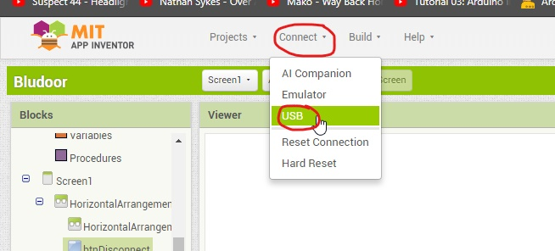

Step 6: Allow usb debugging on the android phone:

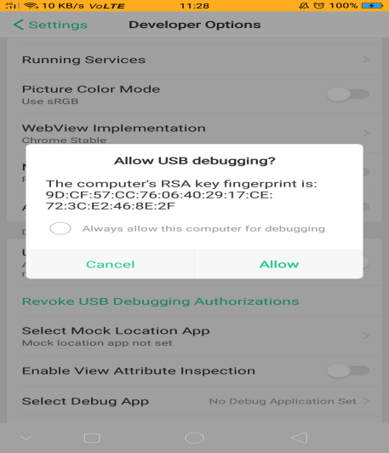

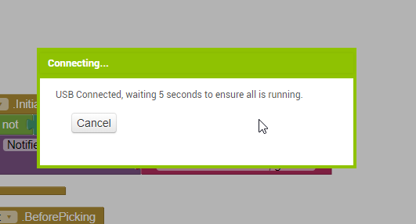

Step 7: Then design the graphical user interface by adding buttons and stuff.

To add buttons just drag the button from the list on the left to the app area as indicated below:

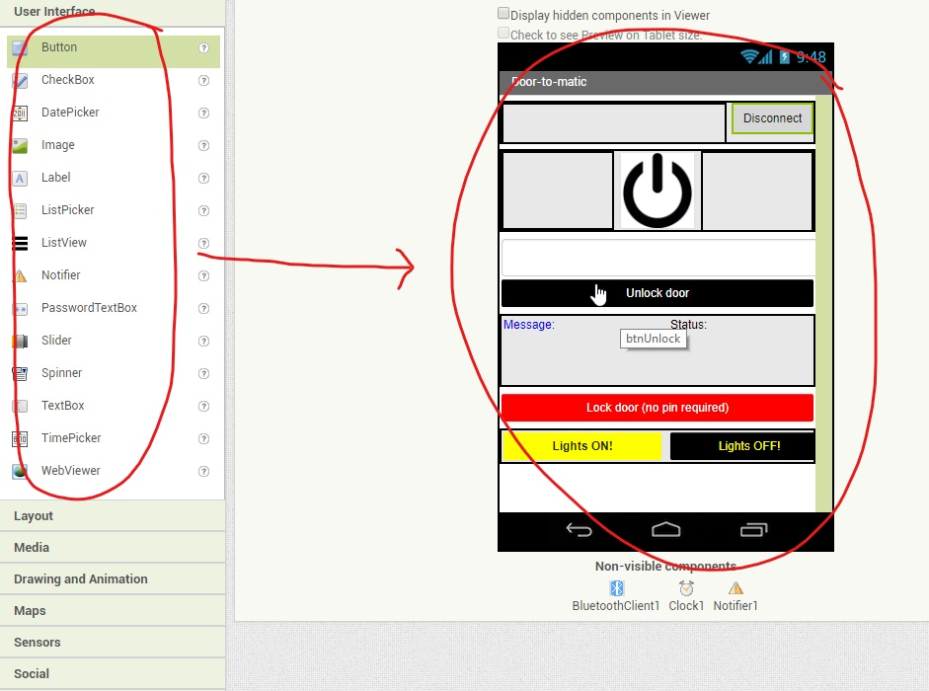

In my case I added:

- 5 Buttons (buttons to disconnect bluetooth, unlock door, lock door, lights on and lights off) 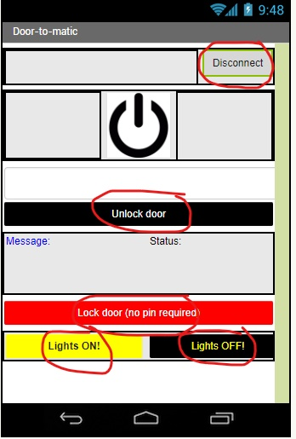

- 2 Labels (to show message and status)

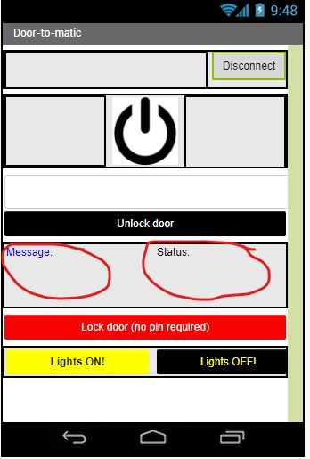

- 1 Textbox (for the user to input the pin to unlock the door)

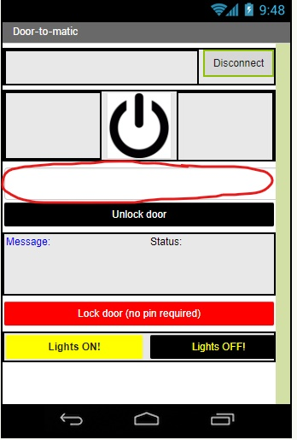

- 1 ListPicker (for the user to select the Bluetooth device to connect to. Note that I changed the design of the ListPicker button to look like a power symbol just for aesthetic purposes)

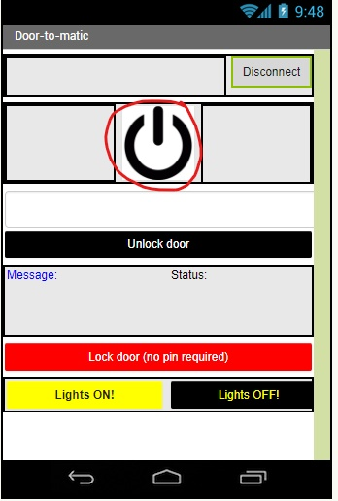

Step 8: Add miscellaneous stuff:

Added stuff from the list on the left by dragging it to the app interface as shown earlier:

-BluetoothClient (to connect and send data to the Bluetooth module)

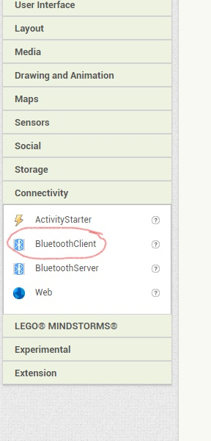

-Clock (So the app can know when to receive data via Bluetooth)

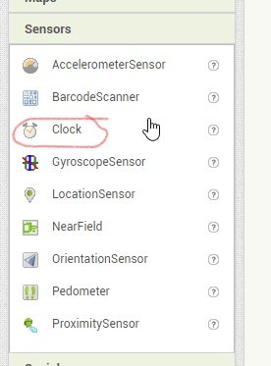

-Notifier(to alert the user when Bluetooth is not enabled on the phone)

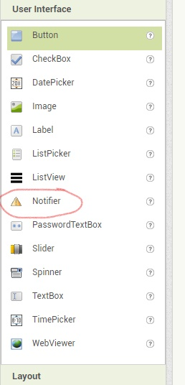

Step 9: Rename the buttons, labels, etc. so that we can identify them so we can code with ease knowing which is which:

By default the buttons will be named as Button1, Button2, Button3, etc. So I changed it to their respective names to make it easier to identify when coding.

To change the name, simply click on the button/label/textbox/listpicker/literally anything, just click on the button/label/textbox/listpicker on the gui, then click rename.

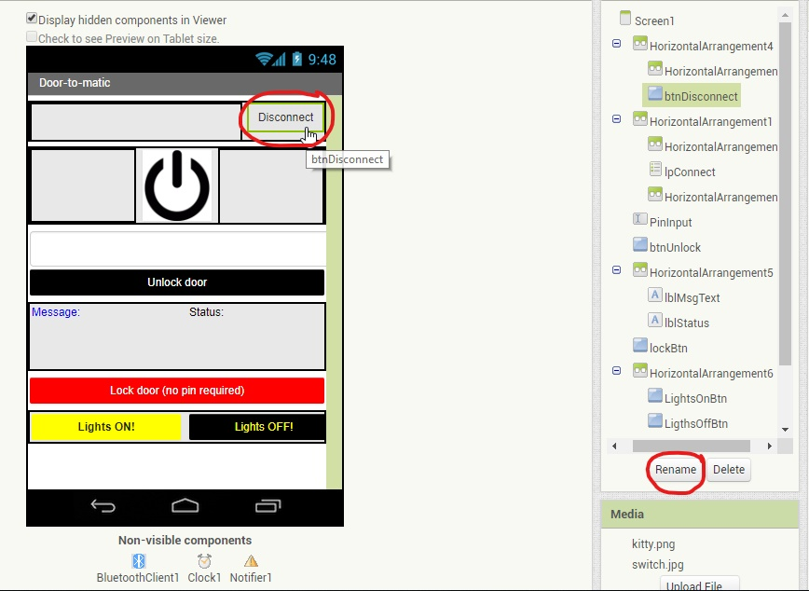

**Here are the button names (on the left is the text, on the right is the name for coding) :**

Disconnect = btnDisconnect

Unlock door = btnUnlock

Lock door (no pin required) = lockBtn

Lights ON! = LightsOnBtn

Lights OFF! = LigthsOffBtn

**The label names (on the left is the text, on the right is the name for coding):**

Message = lblMsgText

Status = lblStatus

**The password textbox (just the name):**

PinInput

**The ListPicker(just the name):**

lpConnect

Step 10: Switch to the Block mode by clicking on the “Blocks” on the top right.

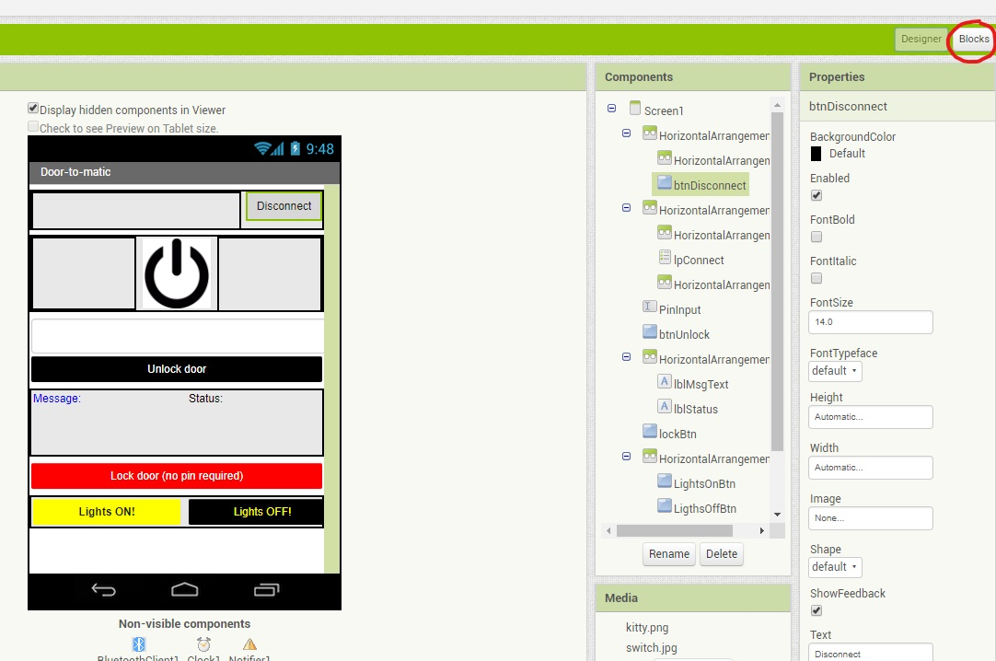

Step 11: Insert codes by dragging the items from the list on the left.

(I’ll show the code after this but basically everything is here. You just gotta drag it on to the white space)

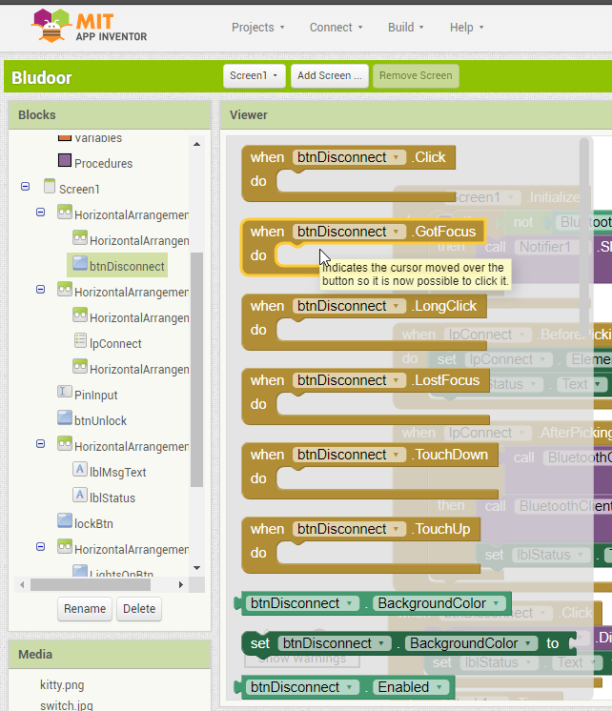

Step 11: After you finish coding, you can download the apk file for the app by clicking on Build > App (save .apk to my computer):

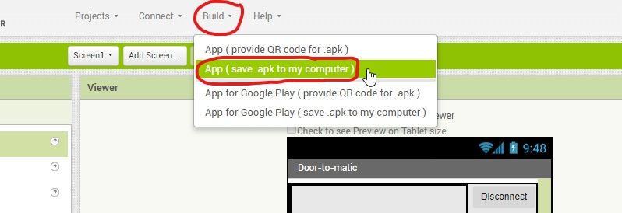

**End of the APP DEVELOPMENT guide.**

App block codes explained:

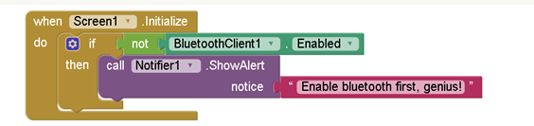

When the user launches the app on phone, the app will check whether Bluetooth is enabled, then alerts the user to enable Bluetooth if it is not on.

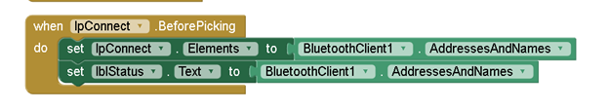

lpConnect is the ListPicker button. When the user clicks it, it will show the droplist of available Bluetooth devices to connect to.

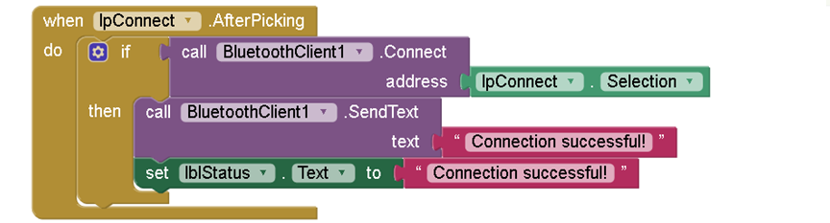

After the user selects, the app will attempt to connect to the selected Bluetooth device.

Then when it is successful it will send data to the Arduino IDE “Connection successful!”.

It will also display “Connection successful!” on the lblStatus.

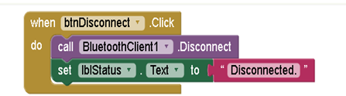

When the user clicks the btnDisconnect, the phone will disconnect from the Bluetooth device and show “Disconnected” on the lblStatus.

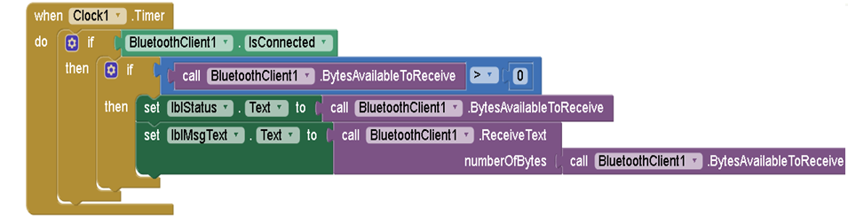

The clock1 is programmed to check if the Bluetooth is connected and will check if any data is being sent by the Arduino.

And if there is data it will receive it and display it on the lblMsgText.

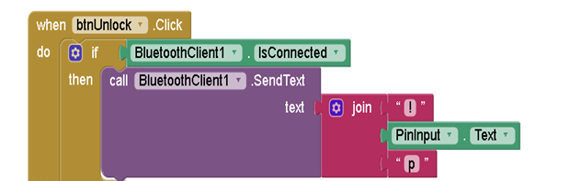

When user clicks the btnUnlock, it will check if Bluetooth is connected.

Then it will combine “!” with the password that the user entered and combine it with a “p” at the end. For example the user inputs a “123456” , the app will then combine it so that it becomes “!123456p” and then sends this to the Arduino. The “!” marks as the start of the password and “p” marks the ending of it as you’ll see later in the Arduino code.

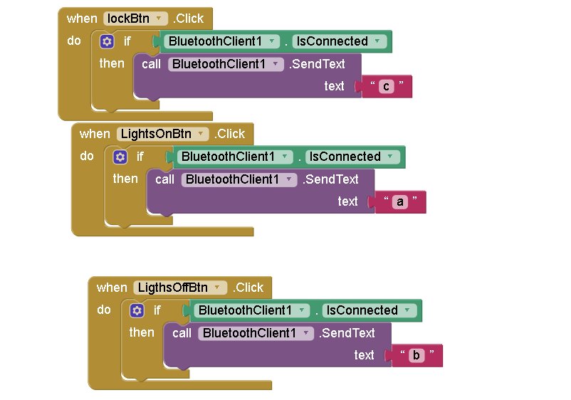

These are pretty self explanatory. When the lockBtn is clicked, it well send a “c” which locks the door, and when LightsOnBtn is clicked, sends a “a”. you get the idea.

Arduino Codes Explained:

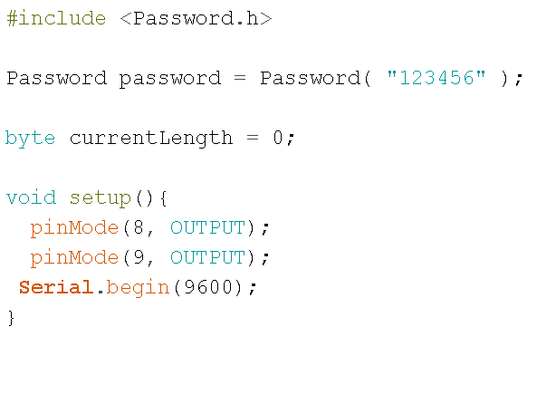#include <Password.h> // *just includes this particular library to be used. This library is Password.h and is used to compare passwords and stuff.*

Password password = Password (“123456”); //*Sets password as a variable. And the password to “123456”.*

Byte currentLength = 0; *//This sets currentLength as a Byte datatype with a value of 0;*

void setup(){ *//anything stored in here runs once , basically the setup..*

pinMode(8, OUTPUT); *//sets pin 8 of the Arduino as output. This is the LED*

pinMode(9, OUTPUT); *//sets pin 9 as the output. This is connected to the relay which controls the door latch*

Serial.begin(9600); *//basically starts the thing and sets baud rate to 9600*

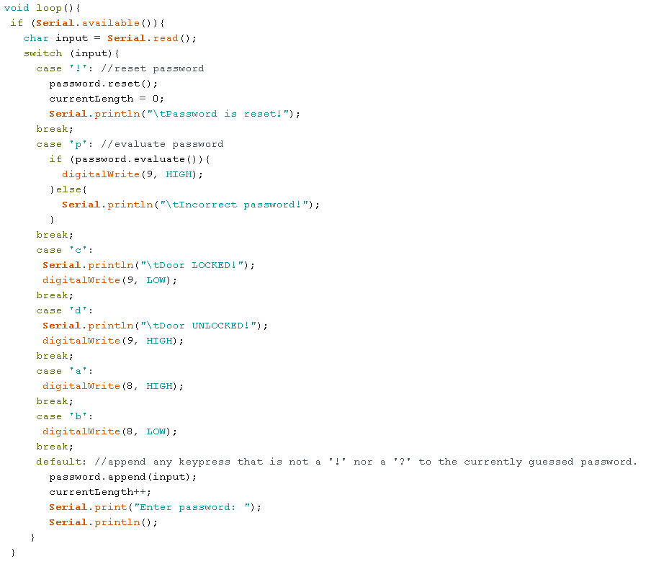

void loop(){ *//everything in void loop basically just loops or repeats itself*

if (Serial.available()){ *//checks if there is data to be received*

char input = Serial.read(); *//creates a char variable called input, and stores data received via Bluetooth in it*

switch (input){ *//switch is used to cycle through the received command(which is a character)*

case '!': //reset password *//when Arduino receives a “!” it will delete the stored password that the user has previously inputted.*

password.reset();

currentLength = 0;

Serial.println("\tPassword is reset!");

break;

case 'p': *//when receive a “p”will compare password that user inputted and if it Is correct will unlock door by outputting high to pin 9 which is the relay that connects to the door latch*

if (password.evaluate()){

digitalWrite(9, HIGH);

}else{

Serial.println("\tIncorrect password!");

}

break;

case 'c': *// when receive a ‘c’, turns off the pin 9, which locks the door latch*

Serial.println("\tDoor LOCKED!");

digitalWrite(9, LOW);

break;

case 'd': *//this was for testing purposes. Was checking to see if the relay worked*

Serial.println("\tDoor UNLOCKED!");

digitalWrite(9, HIGH);

break;

case 'a': *//self explanatory*

digitalWrite(8, HIGH);

break;

case 'b':

digitalWrite(8, LOW);

break;

default: //append any keypress that is not a '!' nor a '?' to the currently guessed password.

password.append(input);

currentLength++;

//Print some feedback.

Serial.print("Enter password: "); *//just prompts user to enter password via terminal*

//for (byte i=0; i<currentLength; i++){

//Serial.print('*');

//}

Serial.println();

}

}

}

Hardware Development

Things you need:

* Arduino UNO
* Breadboard
* Door latch (12V)
* Relay (5V)
* Bluetooth module
* 9V adaptor for arduino
* Phone

Arduino, relay and door latch.

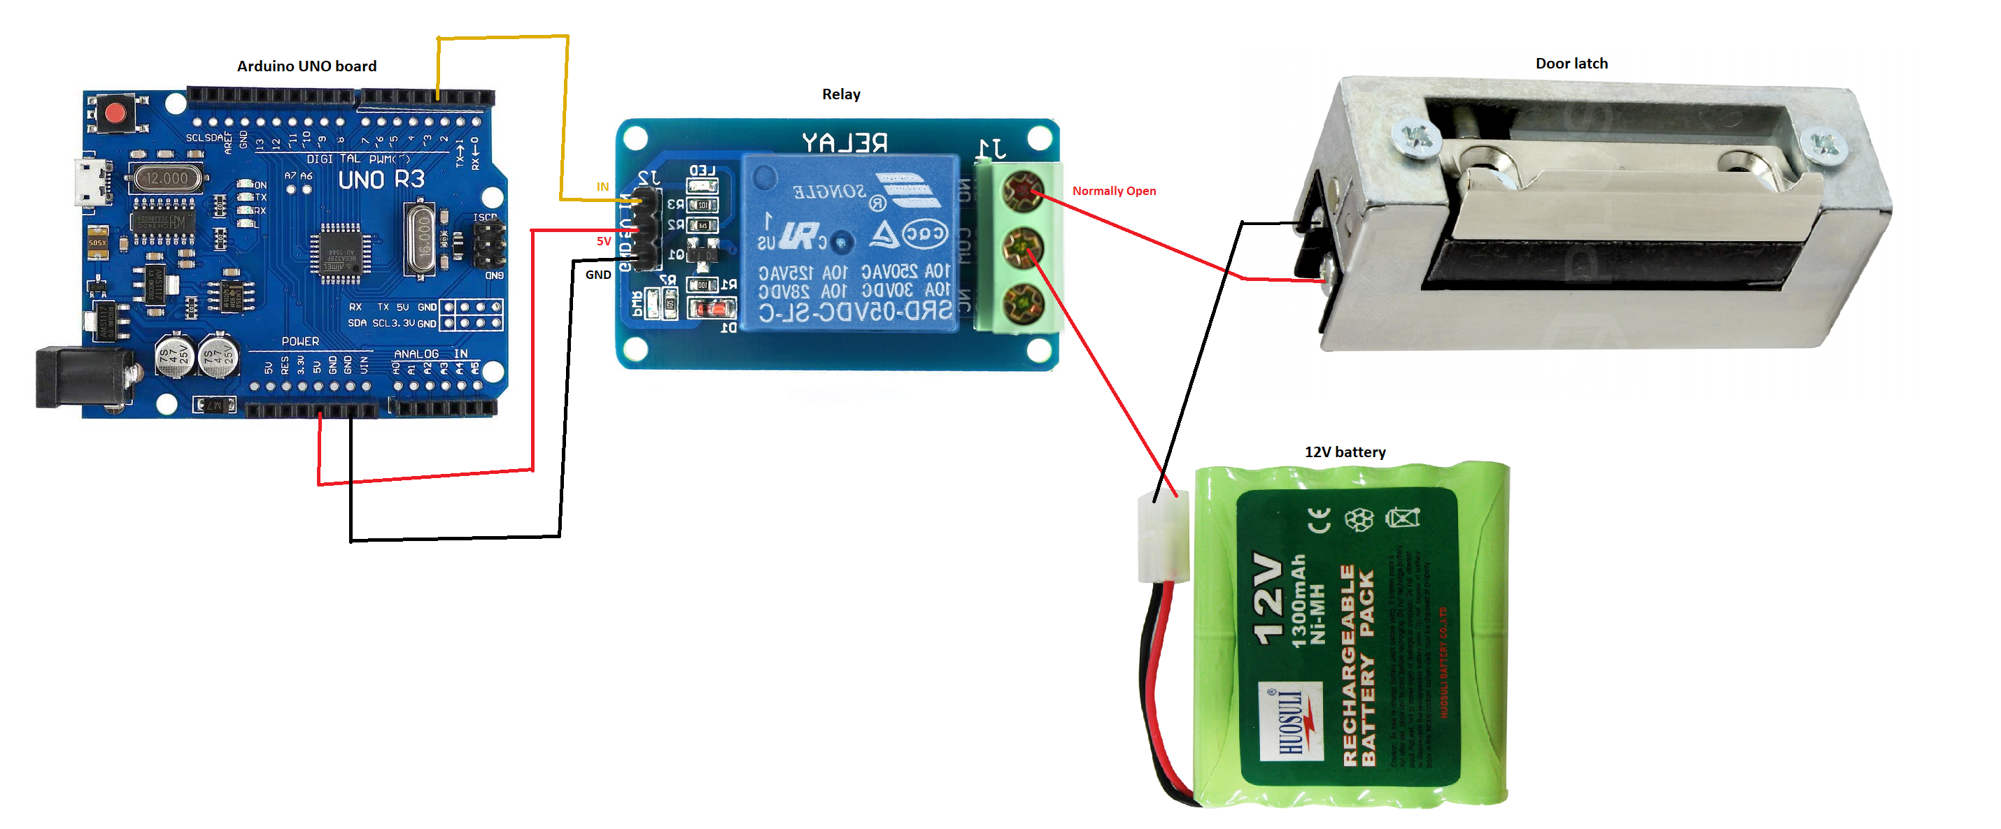

Arduino, Bluetooth module and LED:

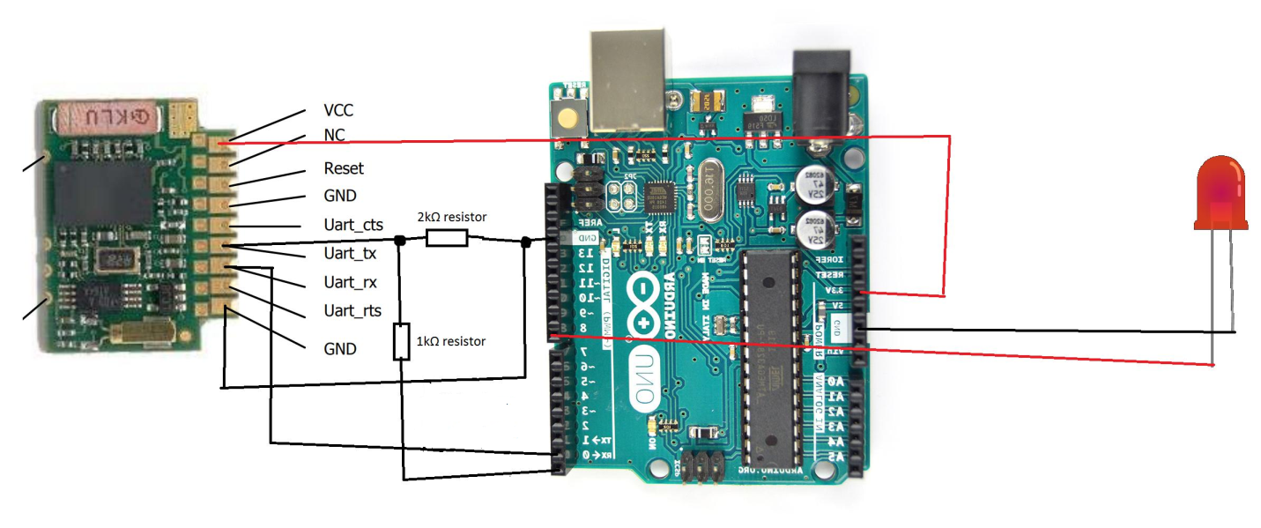

Door latch and relay schematic.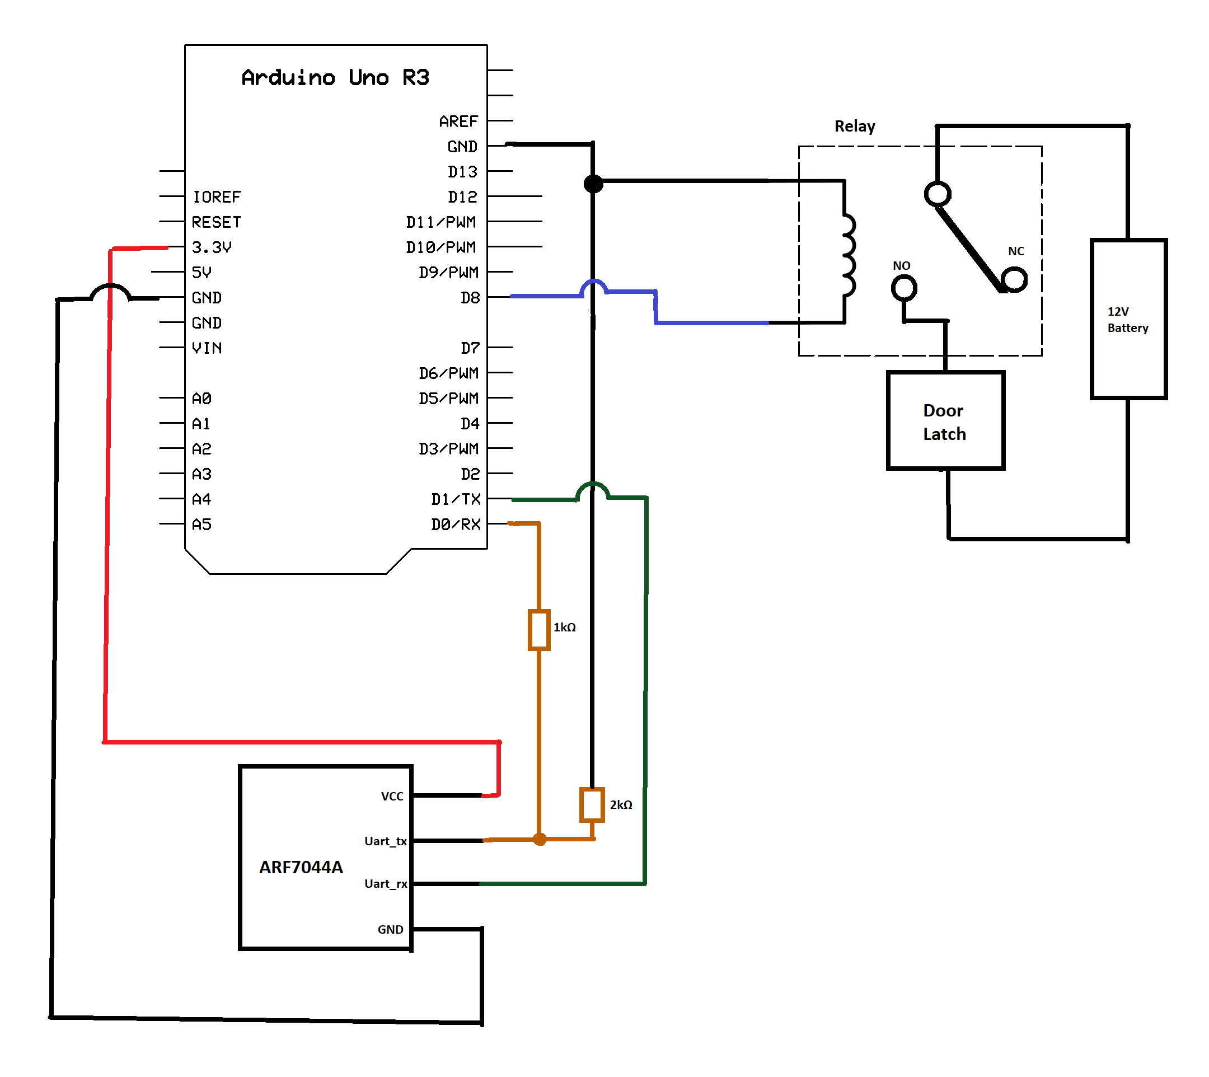

Key technical issues

* The Bluetooth module could not receive data from the phone. (Initially, it could receive data but stopped working.)
* The password doesn’t work.
* The relay doesn’t activate.

Solutions

* Decided to change the Bluetooth module (HC-05) to another Bluetooth module (ARF7044A) as I suspected it was the problem.

After changing it didn’t work either, so I made modifications to the circuitry and it started working. Since it worked with the ARF7044A, I decided to switch back to HC-05 to see if the Bluetooth module was faulty and I was right. It was faulty.

* Changed the code, removed all bugs by adding the semi colons and brackets where needed.
* Changed the relay.

Future Implementation

* An automatic door unlocker when the bluetooth is in range. May not even be bluetooth could be wifi or zigbee.

-can be disabled in settings

* Sensors like fingerprint sensor and facial recognition can be implemented.
* An anti-burglar door system which alerts the user/police when someone tries to break/pick the lock.
* An app for iphone.

Conclusion

In conclusion, here are the things I learnt:

-Arduino

-making apps

-combining the 2 to work together

-troubleshooting skills

-skills that will let me create many things if I want to